**LINE FOLLOWER ROBOT**

DESIGN THINKING PROCESS

# INTRODUCTION

The line follower robot is a mobile machine that can detect and follow the line drawn on the floor. These robots may be used to in various industrial and domestic applications such as to carry goods, floor cleaning, delivery services and transportation.

# REQUIREMENTS

To build a simple robot which can reduce man power and can run in a simple power source and can used for multiple purpose.

# EMPASIZE & RESEARCH

* Man power should be reduced.
* Cost efficient robot.
* Should be capable to run off in simple power source.

# SWOT ANALYSIS

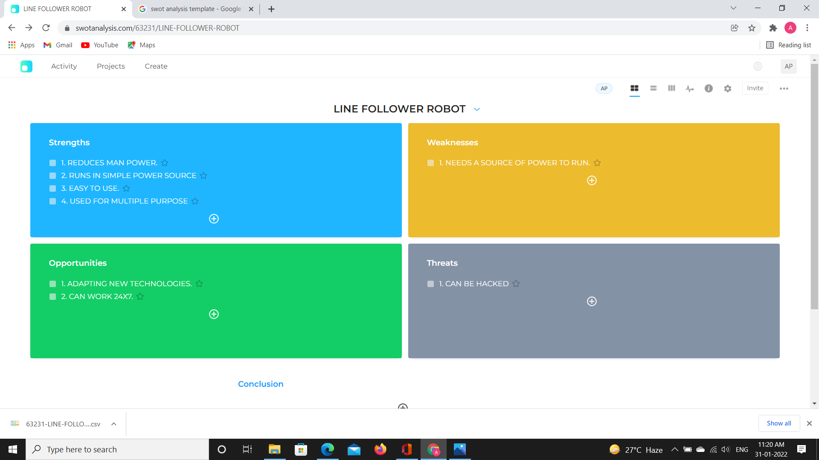

# 5W 1H

## WHO

* Trying to reduce Man Power.

## WHAT

* Robot to reduce Man Power.
* Robot to do different task.

## WHEN

* There is need for replacement to Man Power.

## WHERE

* Need for Cleaning , Lifting Loads etc.

## WHY

* To reduce Man Power.

## HOW

* Apply the method that requires less expenses.

# UML DIAGRAM

